Chemistry 2202 – Formulas and Constants
Constants:
Avogadaro’s # = 6.02 x 10²³
Molar Volume @ STP = 22.4 L/mol
Molar Volume @ SATP = 24.8 L/mol
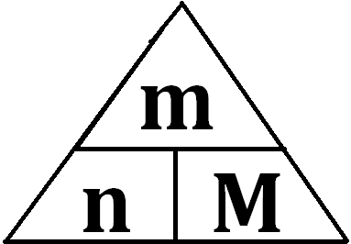
m= mass , M = Molar Mass, n = moles

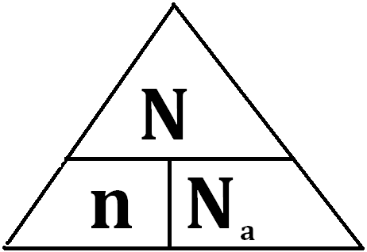
N = Number of Particles, n = moles
Na = Avogadaro’s Number
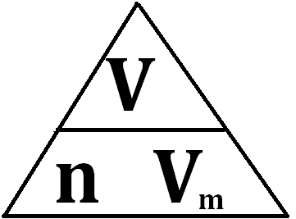

V = Volume, Vm = Molar Volume,
n = moles
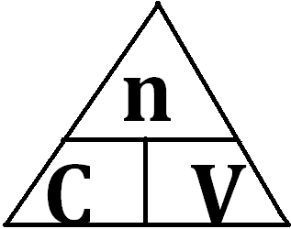
V = Volume , C = Concentration,
n = moles

