Chemistry 2202 - Review of topics from Science 1206

Note: The following worksheets are a review of the Chemical Processes Unit of Science 1206. Students in Chemistry 2202 are expected to have mastered these concepts in the previous school year, as these skills will be essential for success in Chemistry 2202. For students taking Science 1206 and Chemistry 2202 concurrently, it is vital that the following topics are learned quickly, since these topics will not be covered in Science 1206 until later in the fall.

Key Topics:
- Parts of the atom / energy level diagrams
- Naming Molecular Compounds
- Naming Ionic Compounds
- Naming ionic Compounds with Polyatomic ions
- Naming Ionic Compounds with Multivalent Ions
- Balancing Equations
- Significant Digits

- Parts of the atom / energy level diagrams:
The atom is composed of three main sub-atomic particles. They are:
- Protons
  - positively (+) charged particles
  - Are found in the nucleus (center) of an atom
  - Are indicated by the atomic number of an element
- Neutrons
  - Have no charge (neutral)
  - Are found in the nucleus of an atom
  - When added to the number of protons in an element, gives the atomic mass (protons + neutrons = atomic mass)

- Electrons
  - Negatively charged (-) particles
  - Orbit the nucleus of the atom in energy levels
  - In a neutral atom, the number of protons and electrons are equal
Energy Level Diagrams
Atoms can be represented by energy level diagrams, which show the number of each sub atomic particle as well as their location in the atom.
To Create an energy level diagram (example: Carbon)
- Find Carbon on the periodic table ( Symbol C)

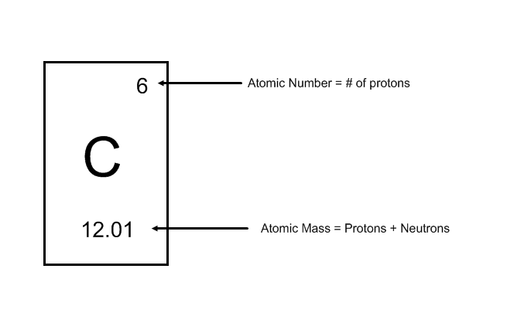
- Determine the number of protons based on the atomic number. (6 in this example)
- Determine the number of neutrons by subtracting the atomic number from the atomic mass. (Note: Round the atomic mass to the nearest whole number, 12)
12 – 6 = 6 neutrons
- Draw the nucleus of the atom as a circle with the number of protons (p) and neutrons (n) written inside.
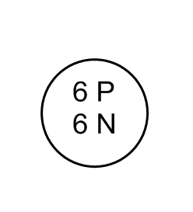
- Determine the number of electrons in the atom. For a neutral atom, the number of electrons will equal the number of protons (see the end note for ions). Carbon has 6 electrons

- Place the electrons above the nucleus of the atom. Remember, each energy level for an atom can only hold a certain maximum of electrons, 2 electrons in the first level, then 8 electrons, then 8 electrons , then 18 electrons. The outermost energy level is call the valence energy level.
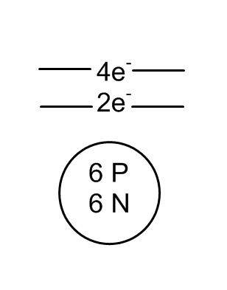
e

Energy level diagram for carbon

Note: Energy level diagrams for ions

For charged atoms (ions) there is one key difference. The number of electrons will vary in an ion. To determine the number of electrons:

For positively charged atoms, take the atomic number and subtract the charge of the atom.

Example: Mg, has an atomic number of 12, so it has 12 electrons.
Mg²⁺ has 12-2 = 10 electrons.
Mg¹⁺ has 12 -1 = 11 electrons.

For negatively charged atoms, take the atomic number and add the charge of the atom.
Example: N has an atomic number of 7, so it has 7 electrons.
N²⁻ has 7 + 2 = 9 electrons.
N³⁻ has 7 + 3 = 10 electrons.
Practice Problems:
- For the first 5 atomic numbers of the periodic table, write down the number of protons, neutrons and electrons.
- Draw energy level diagrams for Na, S, Al and Ne.
- Draw energy level diagrams for Na⁺ Al³⁺, and S²⁻.

- Naming molecular compounds

A molecular compound is made up of 2 or more non-metals. Molecular compounds bond through covalent bonding (sharing of atoms). Use the following prefixes to help you with this section:

1 = mon(o) 2 = di 3 = tri 4 = tetra 5 = penta

6 = hexa 7 = hepta 8 = octa 9 = nona 10 = deca

Determining the name of a molecular compound: example: P₂F₅
- Identify the first element and the number of that element. (2 Phosphorous)
- Identify the second element and the number of that element. (5 Fluorine)
- For the first element, choose the appropriate prefix (Diphosphorous)
- For the second element, choose the appropriate prefix, and add the suffix “ide” (Pentafluoride)
- Put the first and second parts of the name together (Diphosphorous pentafluoride)

Note: If there is only one atom of the first element, we do not use the prefix mono.
(Example: The compound CO₂ is Carbon Dioxide, not Monocarbon Dioxide)
Practice Problems:
- Determine the names of the following molecular compounds.
  - N₂O₄
  - C₄F₁₀
  - H₂S
  - SCl₂
- Determine the formulas for the following compounds.
  - Boron Tribromide
  - Dihydrogen Monoxide
  - Phosphorous Trichloride
  - Heptasulfur Nonaiodide

- Naming ionic compounds

Ionic compounds are formed from a metal and a non-metal. The metal portion of the compound has a positive (+) charge, while the non-metal part has a negative (-) charge.

Note: Recall that groups on the periodic table often have a typical charge associated with them.
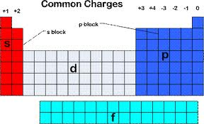

To determine the name of an ionic compound: Example: ZnCl₂

- State the name of the metal (Zinc)
- State the name of the non-metal, and add ‘ide’ (Chloride)
- Zinc Chloride
To determine the formula of an ionic compound: Example: Magnesium Bromide
- Write down the symbol for Magnesium. Also write down its charge. ( Mg²⁺)
- Write down the symbol for Bromine. Also write down its charge. (Br⁻)
- Write down each Symbol, and ‘criss-cross’ the charges.
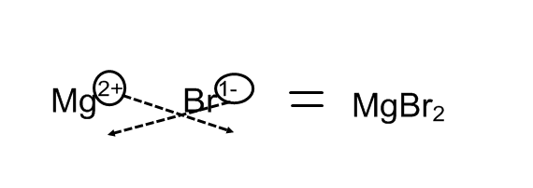
- Reduce the ratio between the numbers if possible (not necessary in this case)
Practice Problems:
- Determine the names of the following ionic compounds:
  - NaF
  - CaCl₂
  - Au₂O
  - Al₃S₂
- Determine the formulas for the following ionic compounds:
  - Barium Iodide
  - Lithium Phosphide
  - Aluminum Nitride
4. Naming Compounds with Polyatomic Ions:
A polyatomic ion is a collection of multiple atoms that act as a single ion. There is a list of common polyatomic ions in this review package. Polyatomic ions typically have their charge indicated. Most polyatomic ions are negatively charged, however one exception is Ammonium, NH4⁺ which takes the place of the metal in the compound.
Naming ionic compounds with polyatomic ions: Example: CaCO₃
- Determine the name of the metal. (Calcium)
- Determine the name of the polyatomic ion ( Carbonate - see list of polyatomic ions)
- Calcium Carbonate.
Example 2: Ba₃(PO₄)₂ Barium Phosphate
Example 3: (NH₄)₂O Ammonium Oxide

Determining the formula of ionic compounds with polyatomic ions: Example: Beryllium Hydroxide
- Write down the symbol for the metal and its charge (Be²⁺)
- Write down the symbol for the polyatomic ion and its charge (OH⁻)
- Write down the symbol and ‘criss-cross’ the charges. If there are more than one of the polyatomic ion, place it in parenthesis.
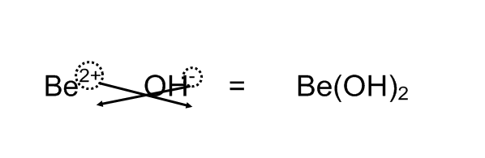
Practice Problems:
- Determine the names of the following ionic compounds:
  - AgNO₃
  - Sc(NO₂)₃
  - CuSO₄
  - Li₂Cr₂O₇
- Determine the formulas for the following compounds:
  - Sodium Chlorite
  - Barium Cyanide
  - Aluminum Permanganate
  - Ammonium Hydroxide

5. Naming Ionic Compounds with Multivalent Ions
Some Ions are able to have multiple charges. For these ions, we use roman numerals to indicate what charge is on the ion. Roman numerals are one (I), two (II), three (III), four (IV), five (V), six (VI), seven(VII).
Naming ionic compounds with multivalent ions: Example Fe(II)O
- State the name of the metal, include the roman numeral ( Iron(II) )
- State the name of the non-metal, add ‘ide’ (Oxide)
- Iron(II) Oxide
Determining the formula of an ionic compound with multivalent ions: Example: Copper(I)Chloride
- Write down the symbol for the metal and its charge (Cu¹⁺)
- Write down the symbol for the non-metal and it’s charge (Cl⁻)
- Write down the symbol and ‘criss-cross’ the charges. Include the roman numeral in the formula, place it after the metal.
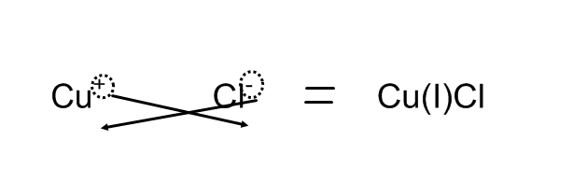
Practice Problems:
- State the name of the following ionic compounds.
  - V(III)Br₃
  - Ni(II)₃P₂
  - Fe(II)O
  - Fe(III)₂O₃
- Determine the formula for the following ionic compounds.
  - Iron(II) Fluoride
  - Mercury(I) Sulfide
  - Manganese(IV) Nitrate
  - Vanadium(III) Phosphide

6. Balancing Reaction Equations (IMPORTANT)
All chemical reactions must obey the law of conservation of mass. This means that the number and type of atoms that are used up in a reaction (the reactants) must be present after the reaction is complete (the products). It is important to be able to balance an equation, since many of the calculations we do in this course are dependent on having reaction equations correctly balanced.
Example 1: Is the following reaction equation balanced?
Mg + O2 MgO
Answer: No, this reaction is not balanced. There are 2 oxygen atoms on the reactant (left) side, but only one on the product (right) side.
To balance a reaction equation:
- Place coefficients (numbers) in front of the reactants or products so there are equal numbers of each atom on both sides.
- Try balancing the element with the greatest number first. Leave any elements that show up in multiple products or multiple reactants until last.
- If there are polyatomic ions present in both the product and reactant, treat them as a single ion.
_2_ Mg + _1_O2 _2_MgO

Practice Problems:
- For each of the following reactions, determine if is balanced or not. If it is not, balance the equation.
  - Cu + AgCl Ag + CuCl₂
  - Pb(NO₃)₂ + KI PbI₂ + KNO₃
  - NH₃ N₂ + H₂
  - HCl + NaOH NaCl + H₂O
  - CH₄ + O₂ CO₂ + H₂O
  - AsCl₃ + H₂S As₂S₃ + HCl
  - C₃H₈ + O₂ CO₂ + H₂O
  - Solid Potassium reacts with Magnesium Chloride to produce Solid Magnesium and Potassium Chloride.
7. Significant Digits (IMPORTANT)
Determining the correct number of significant digits in your calculations, and in your laboratory measurements is a crucial skill to develop in the physical sciences (chemistry and physics). Please pay close attention to the rules of significant digits, as they will be emphasized greatly in this course!
Which numbers are significant?
- Any non-zero digit is significant (1,2,3,4,5,6,7,8,9)
- Any zero that is between two non-zero digits (example: 101, 102324, 1000001)
- If a number contains a decimal, any zeros that come at the end of the number are significant (example: 1.3000, 1.01000)
Which numbers are not significant?
- Any zeros that come before the first non-zero digit (example: 0.00034 has 2 significant digits)
- Zeros that come after the last non-zero digit, when there is no decimal may or may not be significant. In these cases it is best to use scientific notation to avoid confusion.

Example: The number 8200 may have 2,3, or even 4 significant digits. To avoid confusion, we should write the number in scientific notation as such: 8.2 x 10³, showing it has 2 significant digits, or 8.200 x 10³ to show it has 4 significant digits.

Adding and Subtracting Significant Digits:
When adding and subtracting numbers, the answer should have as many decimal places as the least number of decimal places in any of the numbers being added or subtracted.

Examples: 10.44 + 5.1 = 15.54 15.5 8.47 – 3.1 = 5.37 5.4

151 + 0.3 = 151.3 151 4 – 3.3 = 0.7 1

Multiplying and Dividing Significant Digits:
When multiplying and dividing numbers, the answer will have as many significant digits as the number being multiplies that has the fewest significant digits.
Examples: 3.0 x 1.5 = 4.5 3 x 1.5 = 4.5 5 7.74 x 3.000001 = 23.22000774 23.2
6.0 / 1.2 = 5.0 9.75 / 0.25 = 39 9.75 / 0.250 = 39.0

Significant digits will be discussed in greater detail as the course progresses.

Practice Problems:
- How many significant digits does each of the following numbers have?
  - 1
  - 1.0
  - 0.1
  - 0.1000
  - 1.001
  - 0.00100100
- Perform the following calculations. Be sure to get the correct number of significant digits.
  - 3.4 + 8.3
  - 12.2 – 1.41
  - 0.004 + 0.006
  - 1.2 x 10² + 348
  - 3.5 x 15
  - 0.0020 x 99
  - 1.44 x 7.2
  - 95 / 15
  - 95.0 / 15.0

For the first 5 atomic numbers of the periodic table, write down the number of protons, neutrons and electrons.
Name | Protons | Neutrons | Electrons
Hydrogen | 1 | 0 | 1
Helium | 2 | 2 | 2
Lithium | 3 | 4 | 3
Berylium | 4 | 5 | 4
Boron | 5 | 6 | 5

Draw energy level diagrams for Na, S, Al and Ne.
Na: 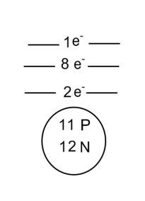S: 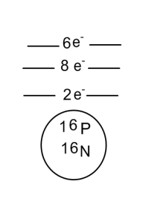Al: 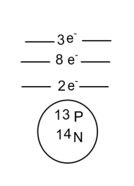Ne: 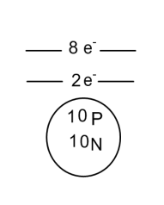
Draw energy level diagrams for Na⁺ Al³⁺, and S²⁻.

Na⁺ 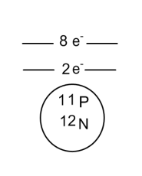Al³⁺ 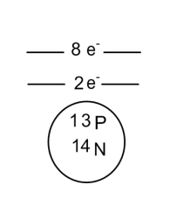S²⁻ 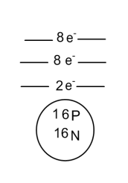
Determine the names of the following molecular compounds.
  - N₂O₄ Dinitrogen Tetraoxide
  - C₄F₁₀ Tetracarbon Decafluoride
  - H₂S Dihydrogen Monosulfide
  - SCl₂ Sulfur Dichloride
Determine the formulas for the following compounds.
  - Boron Tribromide BBr₃
  - Dihydrogen Monoxide H₂O
  - Phosphorous Trichloride PCl₃
  - Heptasulfur Nonaiodide S₇I₉

Determine the names of the following ionic compounds:
  - NaF Sodium Fluoride
  - CaCl₂ Calcium Chloride
  - Au₂O Gold Oxide
  - Al₃S₂ Aluminum Sulfide
Determine the formulas for the following ionic compounds:
- Barium Iodide BaI₂
- Lithium Phosphide Li₃P
- Aluminum Nitride AlN

Determine the names of the following ionic compounds:
- AgNO₃ Silver Nitrate
- Sc(NO₂)₃ Scandium Nitrite
- CuSO₄ Copper Sulfate
- Li₂Cr₂O₇ Lithium Dichromate
Determine the formulas for the following compounds:
- Sodium Chlorite Na₂ClO₂
- Barium Cyanide Ba(CN)₂
- Aluminum Permanganate Al(MnO₄)₃
- Ammonium Hydroxide NH₄OH

State the name of the following ionic compounds.
- V(III)Br₃ Vanadium(III) Bromide
- Ni(II)₃P₂ Nickel(II) Phosphide
- Fe(II)O Iron(II) Oxide
- Fe(III)₂O₃ Iron(III) Oxide
Determine the formula for the following ionic compounds.
- Iron(II) Fluoride Fe(II)F₂
- Mercury(I) Sulfide Hg(I)₂S
- Manganese(IV) Nitrate Mn(IV)(NO₃)₄
- Vanadium(III) Phosphide V(III)P

For each of the following reactions, determine if is balanced or not. If it is not, balance the equation.
- Cu + 2AgCl 2Ag + CuCl₂
- Pb(NO₃)₂ + 2KI PbI₂ + 2KNO₃
- 2NH₃ N₂ + 3H₂
- HCl + NaOH NaCl + H₂O (Balanced Already)
- CH₄ + 2O₂ CO₂ + 2H₂O
- 2AsCl₃ + 3H₂S As₂S₃ + 6HCl
- C₃H₈ + 5O₂ 3CO₂ + 4H₂O
- Solid Potassium reacts with Magnesium Chloride to produce Solid Magnesium and Potassium Chloride.
2 K + MgCl₂ Mg + 2KCl

- How many significant digits does each of the following numbers have?
  - 1 1 SD
  - 1.0 2SD
  - 0.1 1SD
  - 0.1000 4SD
  - 1.001 4SD
  - 0.00100100 6SD
- Perform the following calculations. Be sure to get the correct number of significant digits.
  - 3.4 + 8.3 = 11.7 11.7
  - 12.2 – 1.41 = 10.79 10.8
  - 0.004 + 0.006 = 0.0010 0.0010
  - 1.2 x 10² + 348 = 468 4.7 x 10²
  - 3.5 x 15 = 52.5 53
  - 0.0020 x 99 = 0.198 0.20
  - 1.44 x 7.2 = 10.368 1.0 x 10¹
  - 95 / 15 = 6.33333… 6.3
  - 95.0 / 15.0 = 6.33333… 6.33

