CHEMISTRY 3202

MID-YEAR EXAMINATION

Mealy Mountain Collegiate

PART 1 – SELECTED RESPONSE

**January 2012**

**GENERAL INSTRUCTIONS**

1. This exam consists of 19 pages, including this one. Please ensure all pages are included in this exam.
2. This is Part 1 of a two part exam. It consists of 50 selected response items. The value of this part is 50 points.
3. Please use a blue or black ink pen to write your answers neatly in the spaces provided on answer form (Last page in this part of the exam).
4. The duration of the two part exam is three (3) hours. Part 1 should be completed in one and a half (1.5) hours.
5. Data tables are provided on the back of the exam.
6. Please submit all test materials to your supervisor upon completion of the exam. This includes the questions, answer forms, data tables and any paper used for rough workings, etc.
7. Please attempt all items.

**Selected Response:** Select the response which BEST completes the item and circle the corresponding letter on the answer sheet provided at the end of this section. **Total Value = 50 points, 1% each**

1. What does a thermometer indicate?

A. the average kinetic energy of particles in a substance

B. the energy that flows from system to surroundings

C. the potential energy of particles in a system

D. the velocity of particles in a closed system

2. Which best illustrates an isolated system?

A. aluminum can of cola

B. beaker containing salt solution

C. bomb calorimeter containing sugar

D. sealed glass bottle of oxygen gas

3. Which way does energy flow when a system undergoes an exothermic change?

A. surroundings to system

B. surroundings to universe

C. system to surroundings

D. universe to system

4. Which is a measurement of heat?

A. 3.5 J

B. 5.6°C

C. 98.6 g

D. 273K

5. A 2.50 x 103 g metal alloy has a heat capacity of 1650 J/°C. What is the specific heat capacity of the alloy?

A. 0.660 J/(g°C)

B. 0.850 J/(g°C)

C. 0.900 J/(g°C)

D. 1.56 J/(g°C)

6. Which equation represents the first law of thermodynamics?

A. 

B. 

C. 

D. 

7. What mass of nickel is warmed from 25.0°C to 30.0°C by absorbing 2.50 kJ?

cNi = 0.444 J/(g°C)

A. 0.0888 g

B. 222 g

C. 1.13 kg

D. 5.55 kg

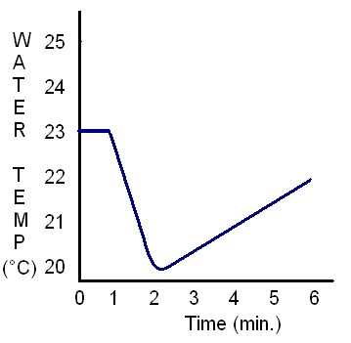

8. Dry ice, CO2(s), is dropped into a beaker of water at time = 1 minute.

The dry ice sublimates: .

What is the best interpretation of the results?

A. sublimation begins at 2 minutes

B. sublimation ends at 2 minutes

C. sublimation is exothermic

D. sublimation warms the water

9. How much energy is gained to increase the temperature of 550 mL of water from 20.0°C to 24.0°C? (density of water is 1g/mL)

A. 2.2 kJ

B. 9.2 kJ

C. 180 kJ

D. 1200 kJ

|  |  |  |  |  |
| --- | --- | --- | --- | --- |
| cmetal (J/g°°C) | 0.900 | 0.385 | 0.129 | 0.444 |

10. 10.0 g pieces of aluminum, copper, gold, and iron, each at 10.0°C, are added to beakers containing equal amounts of water at 80.0°C. Which metal will experience the largest temperature increase?



A. aluminum

B. copper

C. gold

D. iron

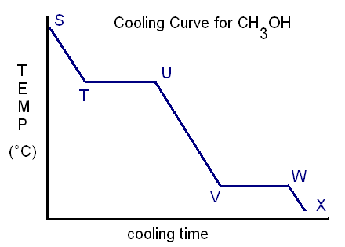11. Which interpretation of the cooling curve of methanol, CH3OH, is correct?

A. T🡪U : methanol melts

B. U🡪V : potential energy is lost

C. V🡪W : solidification occurs

D. W🡪X : kinetic energy is gained

12. What is the symbol representing the enthalpy change due to melting?

A. ∆Hcomb

B. ∆Hfus

C. ∆Hsolid

D. ∆Hvap

13. ∆Hfus for ammonia is +5.65 kJ/mol. What is the enthalpy change for the solidification of 0.420 mol of ammonia?

A. - 13.5 kJ

B. - 2.37 kJ

C. +2.37 kJ

D. +13.5 kJ

14. The enthalpy of the dissolving of NaOH(s) is -44.6 kJ/mol. What is true if a sample of NaOH(s) is dissolved in water?

|  |  |  |
| --- | --- | --- |
|  | Water Temperature | Heat of Solution Formation for NaOH |
| A. | decreases | endothermic |
| B. | decreases | exothermic |
| C. | increases | endothermic |
| D. | increases | exothermic |

15. What is the molar heat of formation of for ethanol?



A. -556 kJ/mol

B. -278 kJ/mol

C. +278 kJ/mol

D. +556 kJ/mol

16. Based on the information below, what is the molar heat of reaction of methane?



A. -336.9 kJ/mol

B. -152.3 kJ/mol

C. +152.6 kJ/mol

D. +336.9 kJ/mol

17. Given these thermochemical equations,



what is the enthalpy change for this reaction?



A. - 292 kJ

B. - 68 kJ

C. + 68 kJ

D. +292 kJ

18. What is the bond energy for the H-X bond?



A. 137 kJ/mol

B. 274 kJ/mol

C. 307 kJ/mol

D. 614 kJ/mol

19. Which best explains why burning hydrogen gas to form water releases approximately seven times the amount of energy released in condensing steam to form liquid water?

A. Burning hydrogen is a chemical reaction.

B. Burning hydrogen is a nuclear change.

C. Condensing steam is a chemical change.

D. Condensing steam is a nuclear change.

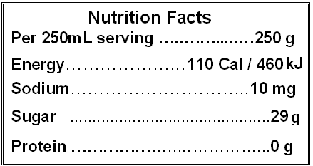

20. What is the fuel value of a common cola given the nutrition facts from the product label?

A. 1.8 kJ/g

B. 2.3 kJ/g

C. 4.2 kJ/g

D. 8.6 kJ/g

21. How many moles of chlorine is required to release 55.8KJ of heat?

H2 + Cl2 🡪 2HCl ∆H = -335 KJ

1. 0.167 moles
2. 0.334 moles
3. 3.00 moles
4. 6.00 moles

22. How much heat is absorbed by a bomb calorimeter if it increases in temperature by 23.2°C ?

Ccalorimeter = 17.9 J/°C

1. 0.772J
2. 1.30J
3. 415J
4. 4.99 x 103 J

23. At standard pressure, which is an example of a change in kinetic energy only?

A. Carbon Dioxide cooling from -80°C to -110°C

B. molten aluminum solidifying at 660°C

C. steam condensing at 100°C

D. water decomposing above 1.0 x 107 °C

24. Which thermochemical equation correctly describes the process represented by the enthalpy diagram to the right?

**Potential Energy**

Progress of Reaction



* 1. 
  2. 
  3. 
  4. 

25. What is the heat of condensation for 15.00 moles of ammonia gas that is liquefying?

(∆Hvap = 23.30 KJ/mol)

1. -349.5 KJ
2. -1.553 KJ
3. 1.553 KJ
4. 349.5 KJ

26. Which observation supports the Kinetic Molecular Theory?

A. Bacon burns black when overcooked.

B. Inflated balloons soften when cooled.

C. Propane produces heat when burned.

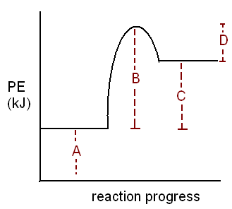 D. Silver bends easily when hammered.

27. Which label represents the activation energy of the reverse reaction?

A. A

B. B

C. C

D. D

28. What is the high energy, unstable species that exists during the transition from reactants to products?

A. activated complex

B. catalyst

C. joule

D. reaction mechanism

29. How does increasing the concentration of a reactant increase a reaction rate?

A. activation energy is decreased

B. collisions become more frequent

C. heat of the reaction is decreased

D. new reaction mechanism is possible

30. Which factor best explains the different reaction rates?



A. catalyst

B. concentration

C. nature of reactants

D. temperature

31. How does increasing the temperature affect the frequency and intensity of collisions between reactant particles?

|  |  |  |
| --- | --- | --- |
|  | Frequency | Intensity |
| A. | decreases | decreases |
| B. | decreases | increases |
| C. | increases | decreases |
| D. | increases | increases |

32. What effect does a catalyst have on an overall reaction?

A. decreases the activation energy required

B. decreases the heat of the reaction

C. increases the frequency of collisions

D. increases the intensity of collisions

***Use the following mechanism to answer questions 33, 34 and 35.***

In the upper atmosphere the destruction of ozone may occur via this mechanism.



33. Which identifies the catalyst and the reaction intermediate?

|  |  |  |
| --- | --- | --- |
|  | Catalyst | Intermediate |
| A. | NO | NO2 |
| B. | NO2 | NO |
| C. | O | O2 |
| D. | O3 | NO2 |

34. Which enthalpy diagram describes this mechanism?

A. 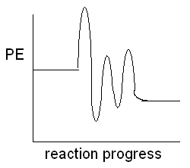 B. 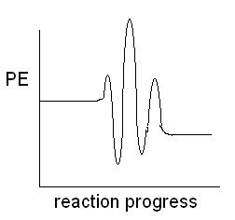

C. 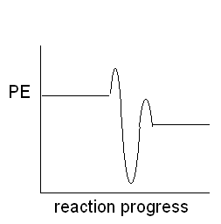 D. 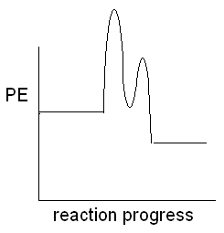

35. Increasing the concentration of which species will increase the overall reaction?

A. NO2

B. O

C. O2

D. O3

36. Which gases are converted by catalytic converters to reduce ground level ozone?

A. carbon monoxide and nitrogen monoxide

B. nitrogen dioxide and carbon dioxide

C. nitrogen and carbon dioxide

D. oxygen and carbon monoxide

37. Which is ***not*** a condition for establishing and maintaining equilibrium?

A. closed system at constant temperature

B. observable properties fluctuate

C. opposing rates are equal

D. reaction is reversible

38. Hydrogen and bromine gas are mixed and equilibrium is established in 60 minutes.

H2(g) + Br2(g) 🡨🡪 2HBr(g)

Which describes the reaction rates?

A. forward rate increases for 60 min.

B. forward rate decreases for 60 min.

C. forward and reverse rates are equal at 30 min.

D. reverse reaction rate decreases for 60 min.

39. What is the effect of warming this system?

4NH3(g) + 5O2(g) ⇌ 4NO(g) + 6H2O(g) + heat

A. [H2O] unchanged

B. [NH3] decreases

C. [NO] increases

D. [O2] increases

40. Which disturbance will increase the pink color of the solution?

Co(H2O)62+(aq) + 4Cl-(aq) + Heat ⇌ CoCl42-(aq) + 6 H2O(l)

PINK BLUE

A. dissolving NaCl

B. evaporating H2O

C. removing Cl- ions

D. warming the container

41. Which is the correct form of the equilibrium constant expression for this reaction?

4KO2(s) + 2H2O(g) ⇌ 4KOH(s) + 3O2(g)

A.  C. 

B.  D. 

42. Compounds X and Y achieve equilibrium with compound Z:

X(g) + 2Y(g) ⇌ 2Z(g)

What is the value of the equilibrium constant if the equilibrium concentrations of the gases are: [X] = 0.8 M, [Y] = 1.2 M, and [Z] = 1.6 M?

A. 0.45

B. 0.70

C. 1.7

D. 2.2

43. At equilibrium, [H2] = 0.12mol/L and [F2] = 0.050 mol/L, what is the [HF] at equilibrium?

H2(g) + F2(g) ⇌ 2HF(g) K = 11

A. 0.023 mol/L

B. 0.066 mol/L

C. 0.26 mol/L

D. 1.8 x 102 mol/L

44. What is the equilibrium concentration of hydrogen in the ICE table?

N2(g) + 3H2(g) ⇌ 2NH3(g)

A. 0.10 I 0.15M 0.40M 0M

B. 0.25 C -------- -------- --------

C. 0.30 E -------- -------- 0.10M

D. 0.50

45. What happens when this system is heated?

N2O4(g) + 59 KJ ⇌ NO2(g) K = 0.22

Colourless Brown

A. the reverse reaction will be favored

B. the value of K is unchanged

C. the value of K will decrease

D. the value of K will increase

46. What is the purpose of a catalyst in a chemical reaction?

A. Decrease Reaction Rate

B. Decrease Yield

C. Increase Reaction Rate

D. Increase Yield

47. Which substance will undergo the fastest combustion reaction?

A. C3H8 (l)

B. C4H10 (l)

C. C5H12 (l)

D. C6H14 (l)

48. Which is true for an endothermic reaction?

A. Forward Activation energy is less than reverse activation energy

B. Forward activation energy is equal to reverse activation energy

C. Forward activation energy is greater than reverse activation energy

D. Forward activation energy + reverse activation energy = 0

49. What would be the best way for monitoring the reaction rate for the following reaction?

Mg(OH)2(s) + 2 HCl(aq) 🡪 2 H2O(l) + MgCl2(aq)

1. Color Change
2. Mass
3. pH
4. Volume

50. Which of the following is true for a catalyst added to a 1.50 mol sample of XY in a 1.0L flask for the following reaction?

XY(g) ⇌ X(g) + Y(g)

1. The equilibrium will be established faster
2. The equilibrium will favor the products
3. The equilibrium will favor the reactants
4. The value of the equilibrium constant will decrease

CHEMISTRY 3202 MID-YEAR EXAM

January 2010

***Please separate this page from the remainder of the test and add it to your answer sheets from Part 2. It should be the first page of your scanned test paper.***

***Be sure to write your name and your school name on ALL written answer pages and be sure to number your pages.***

|  |  |
| --- | --- |
| 1. | 2. |
| 3. | 4. |
| 5. | 6. |
| 7. | 8. |
| 9. | 10. |
| 11. | 12. |
| 13. | 14. |
| 15. | 16. |
| 17. | 18. |
| 19. | 20 |
| 21 | 22. |
| 23. | 24. |
| 25. | 26. |
| 27. | 28. |
| 29. | 30. |
| 31. | 32. |
| 33. | 34. |
| 35. | 36. |
| 37. | 38. |
| 39. | 40. |
| 41 | 42. |
| 43. | 44. |
| 45. | 46. |
| 47. | 48. |
| 49. | 50. |

CHEMISTRY 3202

MID-YEAR EXAMINATION

Mealy Mountain Collegiate

PART 2 – Constructed Response Items

**January 2012**

**GENERAL INSTRUCTIONS**

1. This is Part 2 of a two part exam. It consists of eight (8) major items. **The total value of this part of the exam is 50 points.**
2. Please use a blue or black ink pen to write your answers neatly in the spaces provided on the test paper. There should be sufficient space for your responses; however, if more space is required use an additional unlined 8 ½ x 14” sheet of copy paper and label the responses appropriately. On the main test paper, indicate that the response is continued on the extra page.
3. The full exam (Parts 1 and 2) should be completed in a three (3) hour examination period. Part 2 should be completed in one and a half (1.5) hours.
4. Data tables were provided in Part 1.
5. Please submit all test materials, including sheets containing rough workings, to your supervisor upon completion of the exam.
6. Please attempt all items.

**Part 2 -** Constructed Response Items: *Write a detailed response for each item in the space provided. Show all calculations.* **Value = 50 points**

***Value***

51. A 1.50 kg icicle, H2O(s), at -15.0°C is brought indoors and warmed to room temperature, 22.0°C.

(4) (a) Sketch a labeled heating curve for the warming of the icicle from -15.0°C to liquid water at 22.0°C. Neatly label each: axis, phase change, and type of energy change.

(3) (b) Calculate the total energy change of the H2O. (c ice = 2.01 J/g°C)

(1) (c) Is this process exothermic or endothermic? Briefly explain.

52. In order to determine the enthalpy of neutralization of this reaction,



75.0 mL of 0.500 mol/L HCl(aq) and 75.0 mL of NaOH solution were added to a Styrofoam cup. The initial temperature of both solutions was 19.58°C. After mixing, the highest temperature recorded was 22.67°C.

(1) (a) Identify the system and the surroundings in this calorimetry experiment.

(4) (b) Calculate the molar heat of neutralization (in kJ/mol) for hydrochloric acid.

(1) (c) List two assumptions associated with this experiment and its related calculations.

53. Ethene reacts with fluorine gas.



(4) (a) Calculate the enthalpy change (in kJ) for the reaction using these thermochemical equations. (*Show all workings*)



(1) (b) Would you expect to calculate the same enthalpy change using Bond Energy data? Explain.

(1) (c) Rewrite the overall thermochemical equation including the energy term in the equation.

(3) 54. A. Use the data below to calculate the molar enthalpy of combustion of propane.

C3H8(g) + 5 O2(g) 🡪 3CO2(g) + 4H2O(g)

|  |  |
| --- | --- |
| Bond | Bond Energy (KJ/mol) |
| C-H | 338 |
| C-C | 347 |
| O=O | 498 |
| C=O | 745 |
| H-O | 460 |

(2) B. What is the fuel value of Propane, in Kj/g ?

55.

In a Lab, data from two trials of the reaction below were collected. Graph A illustrates the volume of oxygen produced over time for each trial.

2H2O2(aq) 🡪 2 H2O(l) + O2(g)

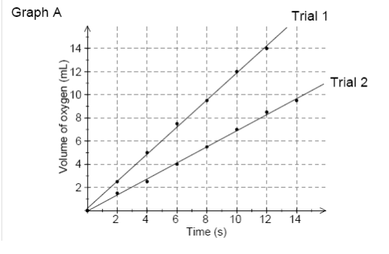

(1) a. Which trial has the highest rate of O2 production?

(2) b.

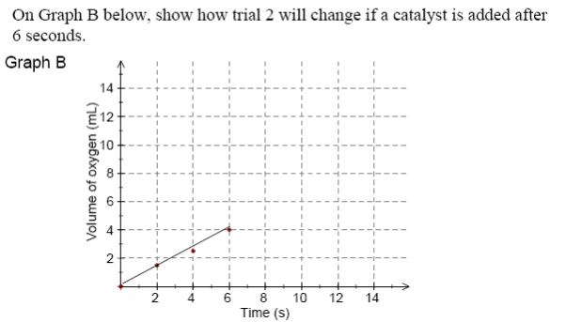

(2) c. Explain how one factor, other than a catalyst, could cause the different rates for trials 1 and 2 shown in graph A.

56. Reacting steam with iron is an old method of producing hydrogen gas. When iron is placed in a container and steam is injected, the system reaches a product-favored equilibrium at 250°C after 30 minutes.

3Fe(s) + 4H2O(g) 🡨🡪 Fe3O4(s) + 4H2(g) + energy

(1) (a) List two changes that could be made to reduce the time it takes to establish equilibrium.

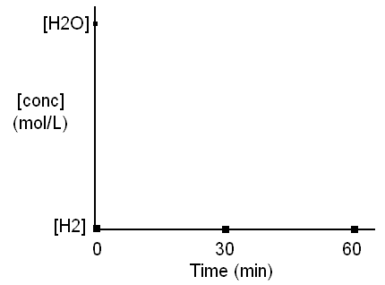

(1) (b) Sketch lines to show the approximate concentration changes for H2O and H2 in this product-favored equilibrium on the graph to the right. (Note the given starting points for each.)

(c) State the effect on equilibrium position resulting from each change imposed on the system. Justify your response using Le Châtelier’s Principle.

(2) (i) cooling the reaction vessel

(2) (ii) adding more H2O(g)

(2) (d) Explain the effect of decreasing the volume of the container on the equilibrium.

57. A sample of 2.80 mol SO3 is injected into an 8.00 L reaction vessel. When equilibrium is established at 130°C, the concentration of SO3 is 0.53 mol/L

(4) (a) Determine the value of the equilibrium constant at 130°C.

2 SO3(g) + energy 🡨🡪 2SO2(g) + O2(g)

(1) (b) Are the reactants or products favored at equilibrium? Explain.

(1) (c) Describe the effect of cooling the system on the value of the equilibrium constant, *K*.

(1) (d) Describe the effect of increasing the volume of the system on the value of the equilibrium constant, *K*.

58. For the following reaction mechanism:

Step 1: X + 2Z 🡪 Y (slow)

Step 2: W + Y 🡪 V + X (fast)

Step 3: V + W 🡪 Q (fast)

(2) a. Draw a potential energy diagram for the reaction, assuming it is exothermic overall.

(2) b. State the overall reaction, and identify the reaction intermediates and catalysts, if any.

1. C. State one way to increase the reaction rate, and state which step you would increase to speed up the reaction.