CHEMISTRY 3202

MID-YEAR EXAMINATION

PART 1 – SELECTED RESPONSE (50 marks)

**January 2013**

**GENERAL INSTRUCTIONS**

1. This exam consists of a total of 23 pages. Page 22 is the answer sheet for your selected response items. Page 23 is provided for extra space. You may remove both of these pages from your exam. Ensure pages 22 and 23 are submitted with your exam.
2. This is Part 1 of a two part exam. It consists of 50 selected response items. The value of this part is 50 points (1 point each). Place your answers to Part 1 on the answer sheet provided (page 22).
3. Please use a blue or black ink pen to write your answers neatly in the spaces provided on answer form
4. The duration of the two part exam is three (3) hours. Part 1 should be completed in one and a half (1.5) hours.
5. A periodic table as well as data tables are provided on a separate page.
6. Please submit all test materials to your supervisor upon completion of the exam. This includes the questions, answer forms, data tables and any paper used for rough workings, etc.
7. Please attempt all items.

**Selected Response:** Select the response which BEST completes the item and circle the corresponding letter on the answer sheet provided at the end of this section. **Total Value = 50 points**

1. What is the definition of temperature?

A. the average kinetic energy of particles in a substance

B. the energy that flows from system to surroundings

C. the potential energy of particles in a system

D. the velocity of particles in a closed system

2. Which system is open?

A. aluminum can of cola

B. bomb calorimeter containing sugar

C. puddle of water on a road

D. sealed glass bottle of oxygen gas

3. Kyla sprains her ankle playing hockey and puts an ice pack on it to cool it down. If her ankle is the system, what is the direction of heat flow and type of energy change taking place?

A. surroundings to system, Endothermic

B. surroundings to system, Exothermic

C. system to surroundings, Endothermic

D. system to surroundings, Exothermic

4. Which relationship illustrates the First Law of Thermodynamics?

A. qsystem = -qsurroundings

B. qsystem = qsurroundings

C. q = mc∆T

D. q = n∆H

5. What is the specific heat capacity of a metal that absorbs 4.95 J of heat when a 2.50 g

sample of the metal increases in temperature from 25.0 OC to 31.0 OC?

A. 0.084 J/(g°C)

B. 0.33 J/(g°C)

C. 3.0 J/(g°C)

D. 12 J/(g°C)

6. Which is an endothermic potential energy change?

A. Water Vapor condensing

B. A copper wire cools by 10OC

C. A piece of gold is heated by 10 OC

D. Iodine crystals undergo sublimation

1. Which best describes the following potential energy diagram?

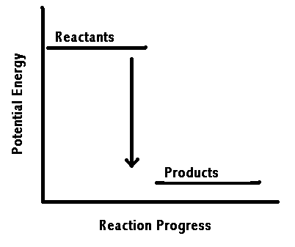

|  |  |  |
| --- | --- | --- |
|  | ∆H | Endothermic or Exothermic |
| A | Negative | Endothermic |
| B | Negative | Exothermic |
| C | Positive | Endothermic |
| D | Positive | Exothermic |

8. What is the final temperature of a 3.00g sample of Nickel at 25.0°C releases 2.50 J of heat?

CNi = 0.444 J/(g°C)

A. 1.88OC

B. 23.12 OC

C. 26.88 OC

D. 33.3 OC

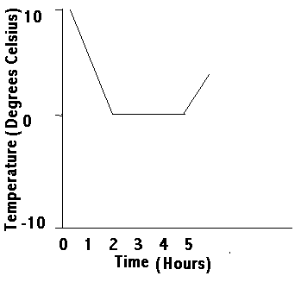

9. A glass of water is left outside one night in October. The temperature of the water over time is shown in the graph.

What is the best interpretation of the results?

A. The water froze completely between 2-5 hours

B. The water melted completely between 2-5 hours

C. The water partially froze then melted between 2-5 hours

D. The ice experienced sublimation

10. A sample of water is heated up by 12.0OC, and absorbes 100.0kJ of energy. What is the mass of the water sample?

A. 1.99g

B. 1990g

C. 5310g

D. 5310KJ

|  |  |  |  |  |
| --- | --- | --- | --- | --- |
| cmetal (J/gOC) | 0.900 | 0.385 | 0.129 | 0.444 |

11. 10.0 g pieces of aluminum, copper, gold, and iron, each at 10.0°C, are added to beakers containing equal amounts of water at 80.0°C. What is the order of the energy increase for the metals, from least amount of energy absorbed to greatest?



Smallest 🡪 Largest

A. Al, Au, Cu, Fe

B. Al, Cu, Fe, Au

C. Au, Cu, Fe, Al

D. Au, Fe, Cu, Al

12. What is the melting point of the substance based on the heating curve?

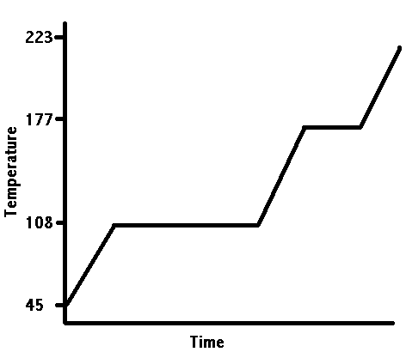

A. 45 OC

B. 108 OC

C. 177 OC

D. 223 OC

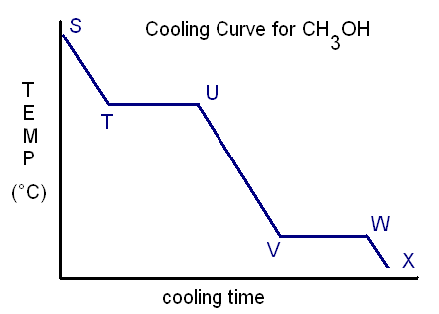13. Which interpretation of the cooling curve of methanol, CH3OH, is false?

A. T🡪U : condensation occurs

B. U🡪V : kinetic energy is lost

C. V🡪W : solidification occurs

D. W🡪X : kinetic energy is gained

14. Given the information for acetone below, which order of changes occurs when acetone is heated from -90.0OC to 60.0OC?

Freezing point = -95.4OC

Boiling point = 56.2OC

A. phase 🡪 temperature 🡪 phase

B. phase 🡪 temperature 🡪 phase 🡪 temperature

C. temperature 🡪 phase 🡪 temperature

D. temperature 🡪 phase 🡪 temperature 🡪 phase

15. What is the symbol representing the enthalpy change due to melting?

A. ∆Hcomb

B. ∆Hfus

C. ∆Hsolid

D. ∆Hvap

16. How much energy is required to vaporize 15.2 g of water at 100OC?

A. 6.36 kJ

B. 34.3 kJ

C. 48.3 kJ

D. 91.5 kJ

17. A sample of Ammonium Nitrate is placed into water and is dissolved. The temperature of the solution decreases by 5OC. What best describes the solution?

|  |  |  |
| --- | --- | --- |
|  | ∆Hsoln | Kinetic Energy Change |
| A | Negative | Negative |
| B | Negative | Positive |
| C | Positive | Negative |
| D | Positive | Positive |

18. What is the molar heat of formation of for 1-hexanol?

1368KJ + 4C6H13OH(l) 🡪 24C(s) + 2O2(g) + 28H2(g)

A. -5472 KJ/mol

B. -1368 kJ/mol

C. -342 kJ/mol

D. 1368 KJ/mol

19. Based on the information below, what is the molar heat of reaction of methane?



A. -336.9 kJ/mol

B. -152.3 kJ/mol

C. +152.6 kJ/mol

D. +336.9 kJ/mol

20. Which does **not** have a standard heat of formation of 0 KJ/mol?

A. Au(s)

B. Br2(g)

C. C(s)

D. H2(g)

21. Which reaction represents the standard formation of sodium hydrogen carbonate, NaHCO3(s)?

A. Na(s) + ½ H2(g) + C(s) + 3/2 O2(g) 🡪 NaHCO3(s)

B. NaHCO3(s) 🡪 Na(s) + ½ H2(g) + C(s) + 3/2 O2(g)

C. Na+(aq) + HCO3-(aq) 🡪 NaHCO3(s)

D. NaHCO3(s) 🡪 Na+(aq) + HCO3-(aq)

22. Given these thermochemical equations:



what is the enthalpy change for this reaction?



A. - 292 kJ

B. - 68 kJ

C. + 68 kJ

D. +292 kJ

23. What is the bond energy for the H-X bond?

H2(g) + X2(g) 🡪2H-X(g) ∆Hrxn = 348 KJ

|  |  |
| --- | --- |
| H-H | 432 KJ/mol |
| X-X | 122 KJ/mol |

A. 103 KJ

B. 122 KJ

C. 206 KJ

D. 412 KJ

24. Which is the correct order of increasing energy changes in terms of magnitude and energies involved?

Smallest 🡪 Largest

A. Nuclear 🡪 Chemical 🡪 Physical

B. Nuclear 🡪 Physical 🡪 Chemical

C. Physical 🡪 Chemical 🡪 Nuclear

D. Physical 🡪 Nuclear🡪 Chemical

25. A student walks to school in 0.50 Hours travelling at 6 km/hr. Before she leaves her house she eats 60.0g of granola. How much energy will remain when she arrives at school?

(FV of granola = 20.3 KJ/g, walking at 6km/hr burns 1675 KJ/hr of energy.)

A. 380 KJ

B. 460 KJ

C. 840 KJ

D. 1200 KJ

26. Which observation supports Kinetic Molecular Theory?

A. A basketball is inflated with air

B. An open bottle of perfume can be smelled across a room

C. Powdered coal is more explosive than lumps of coal

D. Propane produces heat when burned.

***Use the following diagram for questions 27,28 and 29:***

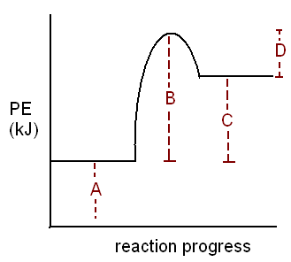

27. Which label represents the activation energy of the forward reaction?

A. A

B. B

C. C

D. D

28. What does label D represent?

A. Activated Complex

B. Activation energy of the forward reaction

C. Activation energy of the reverse reaction

D. Catalyzed reaction mechanism

29. What is the value of ∆H for the forward reaction if its activation energy for the forward reaction is 55.0 KJ and activation energy for the reverse reaction is 25.0KJ?

A. -30.0 KJ

B. 30.0 KJ

C. 40.0 KJ

D. 80.0 KJ

30. What term describes a chemical that gets produced in one step of a reaction, and is then used up in a later step?

A. activated complex

B. catalyst

C. joule

D. reaction Intermediate

31. Which factor explains why coal dust is explosive?

A. concentration

B. pressure

C. surface area

D. temperature

32. Which factor best explains why sodium metal reacts slower than potassium metal?

A. catalyst

B. concentration

C. nature of reactants

D. temperature

33. How does increasing the concentration of reactants affect the frequency and intensity of collisions between reactant particles?

|  |  |  |
| --- | --- | --- |
|  | Frequency | Intensity |
| A. | decreases | decreases |
| B. | increases | decreases |
| C. | increases | no change |
| D. | increases | increases |

34. Given the information below, what is the order of the reaction rates for the trials from fastest to slowest?

|  |  |  |
| --- | --- | --- |
| Trial # | Concentration (mol/L) | Temperature (OC) |
| 1 | 0.0800 | 15 |
| 2 | 0.0800 | 25 |
| 3 | 0.0400 | 15 |
| 4 | 0.0400 | 10 |

Fastest 🡪 Slowest

A. 1🡪2🡪3🡪4

B. 2🡪1🡪3🡪4

C. 4🡪3🡪2🡪1

D. 4🡪3🡪1🡪2

35. What would be the best way for monitoring the reaction rate for the following reaction?

NH3(g) 🡪 N2(g) + 3H2(g)

A. Color Change

B. Mass

C. pH

D. Volume Change

36. What effect does adding a catalyst have on a reaction?

A. decreases the activation energy required

B. decreases the heat of the reaction

C. increases the frequency of collisions

D. increases the intensity of collisions

***Use the following mechanism to answer questions 37, 38 and 39.***

Step 1: CH3OH + HI 🡪 CH3I + H2O (fast)

Step 2: CH3I + CO 🡪 CH3COI (slow)

Step 3 : CH3COI + H2O 🡪 CH3COOH + HI (fast)

37. Which identifies the catalyst and the reaction intermediate(s)?

|  |  |  |
| --- | --- | --- |
|  | Catalyst | Intermediate(s) |
| A. | CH3OH | CH3I, H2O, CH3COI |
| B. | CH3I, H2O | HI |
| C. | HI | CH3I, H2O, CH3COI |
| D. | HI | CH3COOH |

38. Which enthalpy diagram describes this mechanism?

A. 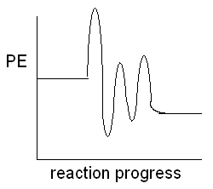 B. 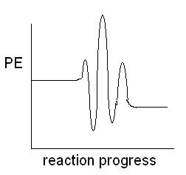

C. 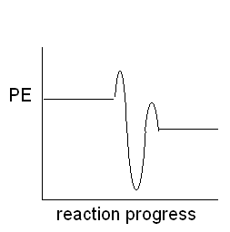 D. 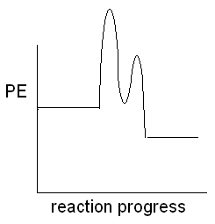

39. How which of the following changes would speed up the reaction the most?

A. Decrease [CH3OH]

B. Increase [CO]

C. Increase [HI]

D. Remove CH3COOH as it forms

40. Which represents the activation energy of the rate determining step?

Ep

**W**

**Y**

Progress of Reaction

**X**

**Z**

A. W

B. X

C. Y

D. Z

41. Which gases are converted by catalytic converters to reduce ground level ozone?

A. carbon monoxide and nitrogen monoxide

B. nitrogen dioxide and carbon dioxide

C. nitrogen and carbon dioxide

D. oxygen and carbon monoxide

***Use the following reaction for questions 42 and 43:***

Phosphorous and Chlorine gas are mixed and equilibrium is established in 60 minutes.

P4(s) + 6Cl2(g)⇌4PCl3(g)

42. What conditions must be met for equilibrium to be established?

A. closed system at constant temperature

B. concentration of reactants and products must be equal

C. no phosphorous solid remains

D. equal volumes of each gas must be present

43. Which statement about the reaction is false?

A. forward rate increases for 60 min.

B. forward rate decreases for 60 min.

C. forward and reverse rates are equal at 30 min.

D. reverse reaction rate decreases for 60 min.

44. What is the effect of increasing the pressure of this system?

4NH3(g) + 5O2(g) ⇌ 4NO(g) + 6H2O(g) + heat

A. [H2O] unchanged

B. [NH3] increases

C. [NO] increases

D. [O2] decreases

45. Which disturbance will increase the blue color of the solution?

Co(H2O)62+(aq) + 4Cl-(aq) + Heat ⇌ CoCl42-(aq) + 6 H2O(l)

PINK BLUE

A. dissolving NaCl

B. cooling the container

C. increase the volume of H2O

D. stirring the solution

46. Which is the correct form of the equilibrium constant expression for this reaction?

4KOH(s) + 3O2(g) ⇌ 4KO2(s) + 2H2O(g)

A.  C. 

B.  D. 

47. Nitrogen gas and Oxygen gas are placed into a container and are allowed to reach equilibrium with Nitrogen Monoxide gas in the following reaction:

N2(g) + O2(g) ⇌ 2NO(g)

What is the value of the equilibrium constant if the equilibrium concentrations of the gases are: [N2] = 0.10 M, [O2] = 0.20 M, and [NO] = 0.0030 M?

A. 4.5 x 10-4

B. 0.15

C. 0.30

D. 2.2 x 103

48. At equilibrium, [H2] = 0.250mol/L and [Cl2] = 0.250 mol/L, what is the [HCl] at equilibrium?

H2(g) + Cl2(g) ⇌ 2HCl(g)  K = 0.275

A. 0.0172 mol/L

B. 0.131 mol/L

C. 2.10 mol/L

D. 4.40 mol/L

49. What is the equilibrium concentration of Chlorine gas in the ICE table?

PCl(g) + 2Cl2(g) ⇌ PCl5(g)

I 0.30M 0.80M 0M

C -------- -------- --------

E -------- -------- 0.15M

A. 0.30 mol/L

B. 0.50 mol/L

C. 0.65 mol/L

D. 0.95 mol/L

50. Which change will result in the value of K increasing?

N2O4(g) + 59 KJ ⇌ 2NO2(g) K = 0.22

Colourless Brown

A. Concentration of NO2 is decreased

B. Pressure of the system is increased

C. Temperature of the system is increased

D. Temperature of the system is decreased

CHEMISTRY 3202

MID-YEAR EXAMINATION

PART 2 – Constructed Response Items (50 marks)

**January 2012**

**GENERAL INSTRUCTIONS**

1. This is Part 2 of a two part exam. It consists of eight (8) major items, and consists of pages 13-21 inclusive. The total value of this part of the exam is 50 points.
2. Please use a blue or black ink pen to write your answers neatly in the spaces provided on the test paper. There should be sufficient space for your responses; however, if more space is required use an additional unlined 8 ½ x 14” sheet of copy paper and label the responses appropriately. On the main test paper, indicate that the response is continued on the extra page.
3. The full exam (Parts 1 and 2) should be completed in a three (3) hour examination period. Part 2 should be completed in one and a half (1.5) hours.
4. A periodic table and relevant data tables are provided on a separate page.
5. Please submit all test materials, including sheets containing rough workings, to your supervisor upon completion of the exam.
6. Please attempt all items.

**Part 2 -** Constructed Response Items: *Write a detailed response for each item in the space provided. Show all calculations.* **Value = 50 points**

***Value***

51. Gallium metal has one of the lowest melting points of all metals at 29.8OC, and can be melted by simply placing it in your hand.

(4) (a) Sketch a labeled heating curve for the heating of 50.0g of Gallium from 22.0°C to 35.8OC. Neatly label each: axis, phase change, and type of energy change.

(3) (b) Calculate the total energy change of the sample of Gallium.

Csolid = 0.371 J/gOC, Cliquid = 0.755 J/gOC, ∆Hfus = 5.59 KJ/mol

(1) (c) Would you expect your hand to feel hot or cold as the Gallium melts? Explain.

52.

NaOH(s) 🡪 NaOH(aq)

A 2.50 g sample of sodium hydroxide is placed into a 150.0 ml volume of water (initial temperature = 21.0OC) and dissolved. The resulting solution has a final temperature of 23.5OC.

(4) (a) Calculate the molar heat of dissolving (in kJ/mol) for Sodium Hydroxide.

(2) (b) List two assumptions associated with this experiment and its related calculations.

53. Iron Oxide reacts readily with Carbon Monoxide gas.

Fe2O3(s) + 3CO(g) 🡪2Fe(s) +3CO2(g) ∆H = ?

(4) (a) Calculate the enthalpy change (in kJ) for the reaction using these thermochemical equations. (*Show all workings*)

1. 3Fe2O3(s) + CO(g) 🡪 2Fe3O4(s) + CO2(g) ∆H =-46.4 KJ

2. FeO(s) + CO(g) 🡪 Fe(s) + CO2(g) ∆H = +9.0 KJ

3. Fe3O4(s) + CO(g) 🡪3FeO(g) + CO2(g) ∆H = -41.0KJ

(1) (b) Would you expect to calculate the same enthalpy change using Bond Energy data? Explain.

(1) (c) Draw a fully labelled enthalpy diagram for the overall reaction.

(4) 54. (a) A 4.75 g sample of airplane fuel is combusted in a bomb calorimeter with a heat capacity of 30.58 kJ/°C. The calorimeter contents increase in temperature from 22.35 °C to 34.90 °C. What is the fuel value of the airplane fuel?

(1) (b) Why is fuel value often used for airplane fuel instead of molar enthalpy of combustion?

55. The reaction between Acetic Acid and Sodium Bicarbonate is measured by the production of Carbon Dioxide gas. The results of the experiment are listed below.

|  |  |  |
| --- | --- | --- |
| Trial # | [CH3COOH] (Mol/L) | Reaction Rate (ml CO2/second) |
| 1 | 0.500 | 15.5 |
| 2 | 0.500 | 16.7 |
| 3 | 0.500 | 9.6 |
| 4 | 0.300 | 4.5 |
| 5 | 0.300 | 5.1 |
| 6 | 0.300 | 5.6 |

(2) a. Calculate the average rate of production of CO2 for the trials 1-3 and for trials 4-6.

(2) b. Explain why the rate of CO2 production is different between trials 1-3 and 4-6, making reference to collision theory.

(1) c. Cold water was used for one of the trials instead of lukewarm water. Which trial most likely used the cold water? Explain your answer.

56. Hydrofluoric Acid can be produced in the reversible reaction between Hydrochloric Acid and Fluorine Gas. A closed reaction flask initially contains Hydrochloric Acid and Fluorine Gas only. It takes 30 minutes for equilibrium to be established.

2HCl(g) + F2(g) ⇋2HF(g) + Cl2(g) + Energy

(1) (a) List one change that could be made to reduce the time it takes to establish equilibrium.

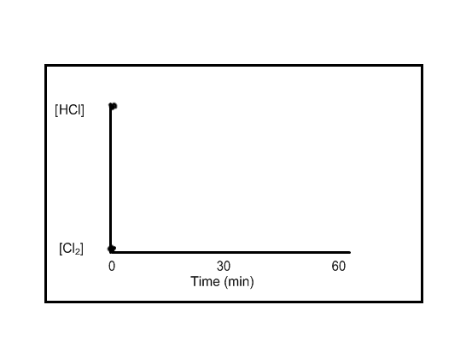

(1) (b) Sketch lines to show the approximate concentration changes for HCl and Cl2 in this reactant-favored equilibrium on the graph to the right. (Note the given starting points for each.)

(c) State the effect on equilibrium position resulting from each change imposed on the system. Justify your response using Le Châtelier’s Principle.

(2) (i) cooling the reaction vessel

(2) (ii) Adding more Cl2(g)

(2) (d) Explain the effect on the equilibrium of increasing the pressure of the container by decreasing the volume.

57. An equilibrium was established in a 1.00 L container when 0.700 mol of phosphorus

pentachloride gas was decomposed at 223OC. At equilibrium, the concentration of chlorine

gas was 0.0740 mol/L.

(4) (a) Determine the value of the equilibrium constant at 223OC.

4PCl5(g) + 75KJ ⇋P4(s) + 10Cl2(g)

(1) (b) Are the reactants or products favored at equilibrium? Explain.

(1) (c) Describe the effect of cooling the system on the value of the equilibrium constant, *K*.

(1) (d) Describe the effect of increasing the volume of the system on the value of the equilibrium constant, *K*.

58. For the following reaction mechanism:

Step 1: ½ O2(g) + NO(g) 🡪 NO2(g) (slow)

Step 2: NO2(g) 🡪 NO(g) + O(g) (fast)

Step 3: O(g) + O2(g) 🡪 O3(g) (fast)

(2) a. Draw a potential energy diagram for the reaction, assuming it is exothermic overall.

(2) b. State the overall reaction, and identify the reaction intermediates and catalysts, if any.

1. C. State one way to increase the reaction rate, and state which step you would increase to speed up the reaction.

CHEMISTRY 3202 MID-YEAR EXAM

January 2013

***Name: ______________________________***

***Please separate this page from the remainder of the test and add it to your answer sheets from Part 2.***

|  |  |
| --- | --- |
| 1. | 2. |
| 3. | 4. |
| 5. | 6. |
| 7. | 8. |
| 9. | 10. |
| 11. | 12. |
| 13. | 14. |
| 15. | 16. |
| 17. | 18. |
| 19. | 20 |
| 21 | 22. |
| 23. | 24. |
| 25. | 26. |
| 27. | 28. |
| 29. | 30. |
| 31. | 32. |
| 33. | 34. |
| 35. | 36. |
| 37. | 38. |
| 39. | 40. |
| 41 | 42. |
| 43. | 44. |
| 45. | 46. |
| 47. | 48. |
| 49. | 50. |

Extra Space: Use this space for workings, etc. This page will NOT be evaluated. Submit this page with the rest of your exam.