Chemistry 3202
Pre-Public Examination
May 2013
Name: _____________
Part 1: Thermochemistry, Kinetics & Equilibrium
This section contains 20 multiple choice and 6 constructed response items covering concepts from the first two units of study. Please answer all multiple choice items on the answer sheet provided. You have one (1) hour to complete this section. If required, an additional 10 minutes will be provided.

A Periodic table as well as a relevant data table has been provided.

Good Luck. Relax, a test is a celebration of your knowledge

Part A: Selected Response. Place your answers at the end of this section (20 marks)
- What term refers to the amount of heat required to raise the temperature of 1 gram of a substance by 1 degree celsius?

A. Calorie
B. Joule
C. Heat Capacity
D. Specific Heat Capacity

- What is the mass of copper that increases in temperature by 15.0^{O}C after it absorbs 350.0J of heat? (c_{Cu} = 0.385 J/g^{O}C)

A. 0.0165 g
B. 8.98 g
C. 60.6 g
D. 2020 g

- Which thermochemical equation matches the enthalpy diagram below?

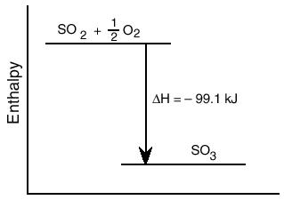
A. SO₂ + ½ O₂ SO₃ + 99.1 KJ
B. SO₂ + ½ O₂ + 99.1 KJ SO₃
C. SO₃ SO₂ + ½ O₂ + 99.1 KJ
D. SO₂ + ½ O₂ SO₃ - 99.1 KJ

4. What is the energy change of a 50.0g mass of water as it condenses?
A. -2040 KJ
B. - 113 KJ
C. 113 KJ
D. 2040 KJ

5. What equipment would be most effective in determining the ∆H_{comb} of Benzoic Acid?
A. Aluminum Can
B. Bomb Calorimeter
C. Stopperd Flask
D. Test Tube

6. A certain process has an enthlapy value of 2.50 x 10⁹ KJ/mol. What type of process is this?
A. Chemical
B. Physical
C. Nuclear
D. Spontaneous

7. What is the total heat change when 15.0g of CH₄ is combusted?
CH_{4(g)} + 2O_{2(g)} CO_{2(g)} + 2H₂O_{(l)} + 890KJ
A. - 952KJ
B. - 832 KJ
C. 832 KJ
D. 952 KJ

8. What is the value of ∆H_{f} for propanol, C₃H₇OH?
Substance | ∆H_{f}
CO₂ | -393.5 KJ/mol
H₂O | -285.8 KJ/mol

C₃H₇OH_{(g)} + 4.5 O_{2(g)} 3CO_{2(g)} +4 H₂O_{(g)} ∆H = -2021 KJ

A. -2323.7 KJ
B. -1341.7 KJ
C. -302.7 KJ
D. 4344.7 KJ

9. Which substance is the least stable?

Substance | ∆H_{f}
CaCO₃ | -1207
CH₄ | -75
C₂H₄ | +52
NO | +90

A. CaCO₃
B. CH₄
C. C₂H₄
D. NO

10. What type of energy change is taking place between points D and E?
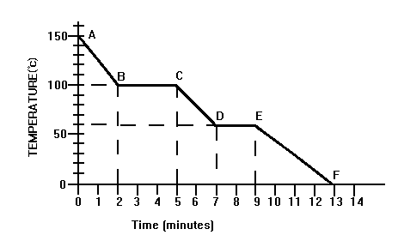

 | Kinetic Energy | Potential Energy
A | Constant | Decrease
B | Decrease | Constant
C | Decrease | Decrease
D | Constant | Increase

Use the following diagram for questions 11 and 12
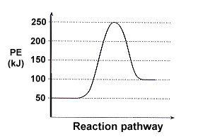
11. What is the activation energy for the reverse reaction in the diagram shown below?

  - -50 KJ
  - 50 KJ
  - 150 KJ
  - 200 KJ

12. What would be the enthalpy for the forward reaction if the reaction was catalyzed?

  - -50 KJ
  - 50 KJ
  - 100 KJ
  - 150 KJ

13. What would be a suitable method for monitoring the following reaction?
Mg(OH)_{2(s)} + 2HCl_{(aq)} H₂O_{(l)} + MgCl_{2(aq)}

- Colour
- Mass
- pH
- Volume

14. What effect does a catalyst have on a reaction?

- Changes ∆H of a reaction
- Decreases the activation energy
- Decreases the potential energy of the products
- Decreases the kinetic energy of the reactants

15. Which step in the following reaction mechanism is the rate determining step?
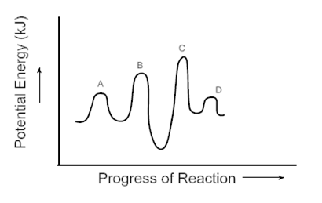

  - A
  - B
  - C
  - D
16. What is not a condition for the establishment and maintenance of a chemical equilibrium?

  - the chemical change must be reversible
  - the concentrations of the reactants must be equal to the concentrations of the products
  - the system must be closed - matter cannot enter or leave the reaction vessel
  - the temperature and pressure of the system must be kept constant

17. What change will result in an increase in the value of the equilibrium constant for the reaction below?
4HCl_{(g)} + O_{2(g)} ⇌ 2H₂O_{(g)} + 2Cl_{2(g)} + 50 KJ

  - Add O_{2(g)} to the reaction vessel
  - Decrease the pressure of the reaction vessel
  - Decrease the temperature of the reaction vessel
  - Remove Cl₂ from the reaction vessel

18. What is the correct equilibrium constant expression for the following reaction?
4Fe_{(s)} + 3O_{2(g)} ⇌ 2Fe₂O_{3(s)}

A. [O₂]³
B. 1 _
[O₂]³
C. [Fe₂O₃]²
[Fe]⁴[O₂]³
D. [2Fe₂O₃]
[4Fe][3O₂]

19. What effect would adding a solution of FeCl₃ have on the following equilibrium?
NH_{3(aq)} + H₂O_{(l)} ⇌ NH₄⁺_{(aq)} + OH⁻_{(aq)}
  - Decrease [NH₄⁺]
  - Decrease [NH₃]
  - Increase [OH⁻]
  - Increase K

20. A sample of NO gas is placed into a sealed flas and is allowed to come to equilibrium as shown below. Once equilibrium is established, [N2] = 0.200M, [O2] = 0.200M and [NO] = 1.80M. What is the value of K in this equilibrium?
N_{2(g)} + O_{2(g)} ⇌ 2NO_{(g)}
  - 1.2 x 10⁻²
  - 9
  - 45
  - 81

Place your answers to the Multiple Choice Section Here
1 | 2 | 3 | 4 | 5 | 6 | 7 | 8 | 9 | 10
11 | 12 | 13 | 14 | 15 | 16 | 17 | 18 | 19 | 20

Constructed Response: Show all workings and use significant digits to receive full marks. (20 marks)

21. Determine the enthalpy of formation for Propane using the following reactions (3 marks):
3C_{(s)} + 4H_{2(g)} C₃H_{8(g)} ∆H = ?

C_{(s)} + O_{2(g)} CO_{2(g)} ∆H = -394 KJ
C₃H_{8(g)} + 5O_{2(g)} 3CO_{2(g)} + 4H₂O_{(l)} ∆H = -2220 KJ
H_{2(g)} + ½ O_{2(g)} H₂O_{(l)} ∆H = -286 KJ

22. Use the information provided to calculate the molar heat of formation for hydrazine, N2H4(g). (3 marks)
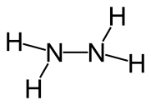
N2(g) + 2H2(g) N2H4(g)

Bond Type | Energy (KJ/mol)
N-N | 160
N-H | 336
N≡N | 945
H-H | 436

23. A 25.0g sample of Arsenic is heated up from 500^{O}C to 613^{O}C and then sublimes into a gas.
a. Draw a heating curve to represent the situation, indicating the type of energy change taking place during each portion of the curve. (1 mark)

If the sample of Arsenic absorbs a total of 20.7 KJ during the process, determine ∆H_{sub} for Arsenic. (C_{Arsenic} = 0.326 J/g^{O}C) (3 marks)

24. A reaction occurs via the following mechanism:

Step 1 Ce⁴⁺ + Mn²⁺ Ce³⁺+ Mn³⁺

Step 2 Ce⁴⁺ + Mn³⁺ Ce³⁺ + Mn⁴⁺

Step 3 Tl⁺ + Mn⁴⁺ Tl³⁺ + Mn²⁺

- Write the overall Reaction (1 mark).

- Identify any catalysts and/or reaction intermediates in the reaction (2 marks).

25. A chemical equilibrium is shown below:
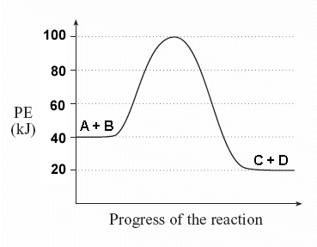
A_{(g)} + B_{(g)} ⇌ C_{(g)} + D_{(g)}

- How would the equilibrium respond to an increase in temperature? Explain using Le Chataliers Principle (2 marks).

- How would the value of the equilibrium constant K change (1 mark)?

26. A 3.00 L reaction vessel is filled with 5.00 mol of HCN(g). Once equilibrium is established, 45.0% of the HCN has decomposed. Determine the value of K for the following reaction (4 marks).
2HCN_{(g)} ⇌ N_{2(g)} + C₂H_{2(g)}

Chemistry 3202
Pre-Public Examination
May 2013
Name: _____________
Part 2: Acids and Bases, Electrochemistry
This section contains 20 multiple choice and 6 constructed response items covering concepts from the first two units of study. Please answer all multiple choice items on the answer sheet provided. You have one (1) hour to complete this section. If required, an additional 10 minutes will be provided.

A Periodic table as well as a relevant data table has been provided.

Good Luck. Relax, a test is a celebration of your knowledge

Part A: Selected Response. Place your answers at the end of this section (20 marks)
            - Which statement operationally describes Ammonia, NH₃?

  - Ionizes to produce OH⁻
  - pH = 5.0
  - Tastes bitter
  - Turns blue litmus red

            - What is the conjugate base of HSO4⁻?

- H₂SO₄
- H₃O⁺
- OH⁻
- SO₄²⁻
            - In the following reaction, which substances make up the acid/conjugate base pair?

CO₃²⁻_{(aq)} + H₂O_{(l)} ⇌ HCO₃⁻_{(aq)} + OH⁻_{(aq)}
A. CO₃²⁻ / HCO₃⁻
B. CO₃²⁻ / OH⁻
C. H₂O / HCO₃⁻
D. H₂O / OH⁻

            - Four solutions, each with a concentration of 0.10M are tested for their chemical and physical properties; a strong acid, a weak acid, a strong base and a weak base . The results are shown below:

Substance | Reactivity with Magnesium | Electrical Conductivity
I | None | High
II | Vigorous | High
III | Moderate | Low
IV | None | Low

Which substance is the weak acid?
- I
- II
- III
- IV

            - Which substance is the strongest base?

- CH3OO⁻
- HSO₄⁻
- Cl⁻
- H₂O

            - What is the pOH of a 0.0200M solution of HClO₄?

  - 5.00 x 10-¹³
  - -1.699
  - 1.699
  - 12.301

            - What occurs when the pH of a solution changes from 7 to 9?

              - [H3O⁺] doubles
              - [H3O+] increases by 100 times
              - [OH-] doubles
              - [OH-] increases by 100 times

            - What term refers to when equal molar amounts of acid and base have been added during a titration?

- Acid Equilibrium Point
- Buffer Zone
- Endpoint
- Equivalence Point

            - What is a possible pOH value for the solution described below?

Indicator | Colour
Methyl Violet | Blue
Litmus | Red

- 1.00
- 2.00
- 12.00
- 13.00

            - What would be required to precisely determine the concentration of a titrant prior to performing a titration?
              - Buret
              - Indicator
              - Pipette
              - Primary Standard

Use the following graph to answer questions 11 and 12:
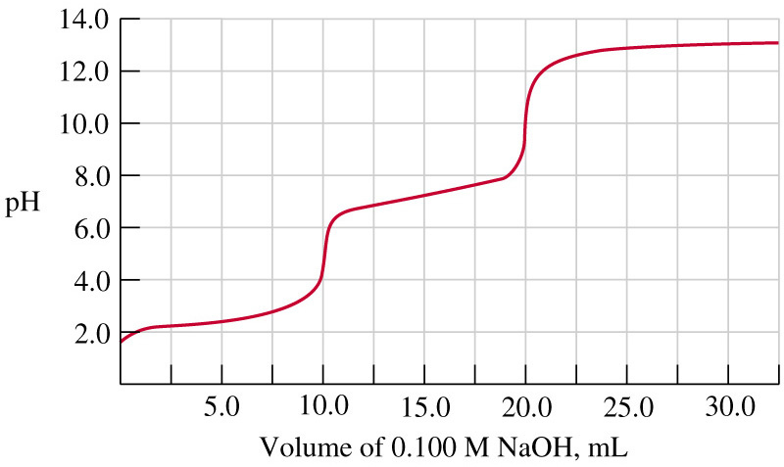
            - Which acid could produce the above titration curve?
              - HCl
              - H₂CO₃
              - HPO₄²⁻
              - NH₄⁺

            - Which indicator would have a yellow colour after 20.0 ml of NaOH has been added?

              - Bromocresol Green
              - Bromothymol Blue
              - Methyl Red
              - Methyl Violet

13. Which defines oxidation?
  - gain of protons
  - gain of electrons
  - loss of protons
  - loss of electrons

14. Which substance is the best reducing agent?
  - Au_{(s)}
  - H₂O_{(l)}
  - I⁻_{(aq)}
  - K⁺_{(aq)}

15. What is the oxidation number of Br in KBrO₃
- -1
- +1
- +5
- +6

6. Which substance is the oxidizing agent in the following reaction?
2Fe²⁺ + H₂O₂ + 2H⁺ 2Fe³⁺ + 2H₂O
- Fe²⁺
- Fe³⁺
- H⁺
- 1H₂O₂

17. Which half-reaction is an oxidation that would require an inert electrode?
- Cu²⁺_{(aq)} + 2e⁻ Cu_{(s)}
- 2Cl⁻_{(aq)} + 2e⁻ Cl_{2(g)}
- H_{2(g)} 2H⁺_{(aq)} + 2e⁻
- Pb_{(s)} Pb²⁺ + 2e⁻

Use the following diagram to answer questions 18-20:
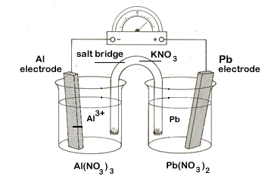
18. What substance is the cathode in this cell?
- Al
- Al³⁺
- Pb
- Pb²⁺

19. What statement correctly describes the movement of charges in the cell?
- K⁺ ions move toward the anode, e⁻ move toward the cathode
- K⁺ ions move toward the cathode, e⁻ move toward the anode
- NO₃⁻ ions move toward the cathode, e⁻ move toward the anode
- NO₃⁻ ions move toward the anode, e⁻ move toward the cathode

20. What is the voltage for the cell?
- -1.79V
- -1.53V
- 1.53V
- 1.79 V
Place your answers to the Multiple Choice Section Here
1 | 2 | 3 | 4 | 5 | 6 | 7 | 8 | 9 | 10
11 | 12 | 13 | 14 | 15 | 16 | 17 | 18 | 19 | 20

Constructed Response: Show all workings and use significant digits to receive full marks. (20 marks)
21.

- Determine the Bronstead-Lowry reaction that takes place when a solution of NaH₂PO_{4(aq)} is mixed with a solution of NaOH_{(aq)}. (2 marks)

  - Which side of the reaction is favored? Explain. ( 1 mark)

22. A solution of 0.350M Ethylamine is prepared in water as shown below. Calculate the expected pH of the solution if the Kb for Ethylamine is 4.27 x 10⁻⁴. (4 marks)
C₂H₅NH_{2(aq)} + H₂O_{(l)} ⇌ C₂H₅NH₃⁺_{(aq)} + OH⁻_{(aq)}

23.
A. A primary standard of Na2CO3 is used to determine the concentration of a solution of Hydrochloric Acid. In the first trial of the experiment, 20.20ml of HCl_{(aq)} is required to neutralize 0.4750g of Na2CO3. Determine the concentration of the HCl solution. (3 marks)
Na₂CO_{3(aq)} + 2HCl_{(aq)} H₂O_{(l)} + CO_{2(aq)} + 2NaCl_{(aq)}

B. Draw a titration curve for the reaction taking place in A. Ensure the correct general shape for the curve is shown as well as measured volumes for the titrant. (2 marks)

24. Balance the following redox reaction under Acidic Conditions. (3 marks)
Cu_{(s)} + HNO_{3(aq)} Cu²⁺_{(aq)} + NO_{(g)}

25. An electrochemical cell is produced according to the cell notation below. It produces a current of 0.550mA.
Sn_{(s)}/Sn²⁺_{(aq)} // Au³⁺_{(aq)}/Au_{(s)}

- Calculate the voltage produced by this cell. (2 marks)

- Determine the time required to produce 1.00g of gold. (3 seconds)

Extra Paper: This work will not be evaluated unless explicitly stated.

