Math 1202 Midterm Review
Name: ____________________________________________

Chapter 1

1. While at Home Hardware Rylan Stern noticed that he could buy nails in the ways shown
below. Which has the lowest unit price?
A) 75 nails for $2.99 or 150 nails for $5.50
B) 12 oz can of soup at $2.39 or a 18 oz can at $3.69?
C) 200 bricks at $193.40 or 260 brick at $274.30?
D) 16 kg bag of flour at $7.19 or 20 kg bag at $9.29?
E) 1 liter of paint at $12.37 or 3.78 liters at $43.20?
2. Calculate the percent decrease or increase.
A) Last winter, the cost of strawberries was $3.15/lb. This winter, the cost is $2.50/lb.
B) The original price of a lazy boy recliner valued at $929.00 with a mark down to $799.95.
C) Brady bought a BBQ to surprise his Mom while it was on clearance sale this fall. The
model he chose was originally priced at $349.99 but was marked down to $279.99.
D) A stereo originally priced at $299.99 are increased to $324.99.
E) Hairstyling scissors originally priced at $95.99 are increased to $119.99.
3. The normal temperature for a dog is from 99⁰ F to 102⁰F.
A) What are these temperatures in degress Celsius?
B) Ashley’s dog has a temperature of 40⁰C. Does this fall in the normal range?

4. A) Convert 25 degrees Celsius into Fahrenheit.
B) Convert 212 degrees Fahrenheit into Celsius.
5. The average March temperature in the city of Regina is −3 degrees Celsius. What is
the equivalent temperature in degrees Fahrenheit?
6. The average temperature in Fort Nelson is -1.9°C. The average temperature
in Moscow, Russia is 42.4°F. Which temperature is higher and by how
much? (You can use either Fahrenheit or Celsius.)

7. You have been asked to ship a package that weighs 41 kilograms. However, the freight
company wants to know the weight in pounds. What is the closest approximation of the
package's weight in pounds?

8. If a basket of raspberries weighs 12 ounces and you need 4 kilograms to make jam, how
many baskets do you need to buy?
9. If it costs $2.10 for 100 g of white fish, how much will it cost to buy 350 g?

10. Karen is making a batch of potato soup. She needs 8 potatoes, and each
potato weighs about 375 g. How many pounds of potatoes does she need?

11. A) What metric unit of measure would best describe the weight of a
pencil?
B) What imperial unit of measure would best describe the weight of a
dog?
12. The cost of 12 hamburger buns is $3.49 and the cost of 8 hamburger patties is $9.50.
Calculate the unit price of one hamburger [bun and patty].
13. The cost of 8 hot dog buns is $2.49 and the cost of 10 tofu wieners is $2.98.
Determine the unit price per serving (1 bun + 1 wiener).

14. Your friend Bob and his parents are going to Disneyland. They invite you to
come along and tell you all you need to do is bring money to get into
Disneyland and pay for food while you are there. They tell you to bring the equivalent of $300 Canadian in American dollars. How much American money is $300 Canadian? (1 American dollar = $1.038650 Canadian)
15. Marian travels to Spain to visit her mother and father. During her visit she buys a leather
purse for 125 Euros? What is the cost in Canadian dollars? (1 CAD = 0.680228 Euro)

16. In 2008, Sasha was travelling from Aberdeen, Scotland, to Toronto, Canada. She changed
her 675.95 British pounds (GBP) to Canadian dollars (CAD) upon her arrival. How many
Canadian dollars did she receive? (1 GBP = 2.20 CAD)

17. You are planning to attend Project Help Mexico with the school this year so
you can build houses for families in Mexico. The teacher in charge of the trip tells you to bring along approximately 1200 pesos. How much will that cost you in Canadian dollars? (1 peso = $0.108443 Canadian)

Chapter 2

1. A drawer is 11 inches wide. Estimate this width in centimetres.

2. What is the circumference of a circular fountain if its radius is 5.3 m?

3. A two—dollar coin is approximately 28 mm in diameter.
A) What is the width in centimetres?
B) What is the width in metres?
4. Which SI unit is most appropriate for measuring the distance from Wabush to Labrador
City?

A) Centimetres
B) Kilometres
C) Metres
D) Millimetres
5. Convert 29 miles to the nearest kilometre.
6. The length of a fireplace mantle is 6 ' 9". Express this length in metres.
(Hint: Change to inches first, then cm, then metres).
7. On a road map of British Columbia, the distance between Vancouver and Fort St. John is
1237 km. What is this distance to the nearest mile?
8. Find the perimeter or circumference of each figure
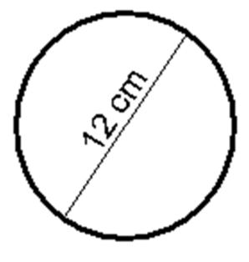
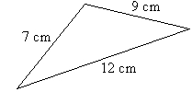

9. Abigail is 62 inches tall. What is Abigail’s height in feet and inches?
10. How long is this bandage to the nearest inch?

11. Which of the following would you most likely use centimeters to measure?
A) distance an airplane travels
B) height of a doorway
C) length of a piece of notebook paper
D) width of a dime

12. A letter-size sheet of copy paper is 216mm by 279 mm. What are its dimensions in
inches?
13. A picture measures 42 cm across. What is this measurement to the nearest inch?

14. Tanner’s sprinkler spreads water in a circular pattern. When he fully opens the faucet, the
circle has a radius of 22 ft. If Tanner walks around the edge of the circle, how far does
he walk? Use 3.14 for π.

15. A circle has a circumference of 112.6 m. What is the diameter of the circle?
Use 3.14 for π.
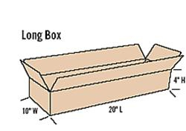
16. What is the girth of the following package?

17. Charlie drove from Calgary to Saskatoon, which is a distance of 620 km. How far is this
in miles?
18. While driving in the US, Franklin, see that the height of a tunnel is marked as 10'6".
He knows that his truck is 3.2 m tall. Can he drive through the tunnel?
19. The distance from Vancouver to Seattle is 220 km. What is this distance in miles?

20. Billy is 6 2" inches tall. What is Billy’s height in centimeters?
21. Jasmine is making a display board for the school talent show. The display board is a 10'8"
by 9'11" rectangle.
A) What will the perimeter of the board be in feet and inches?
B) If ribbon costs $0.22 per cm, how much will it cost to add a ribbon border
around the entire display board?

22. A rectangular school yard 260 meters by 275 meters is to be fenced. How
many feet of fencing will be required to fence it completely?
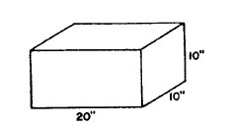
23. What is the girth of the following packages?
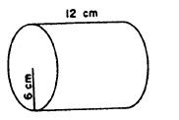
a) b)

24. Darma is edging a tablecloth with lace. The tablecloth is 210 cm by 180 cm.
How much lace does she need?

Chapter 3

1. A rectangular tabletop is 3 feet long and 28 inches wide. Which is the area of the
tabletop?
2. The radius of a circle is 13.6 meters. What is the approximate area?
3. The area of a picture is 1456 mm² . Express this area in cm² .

4. Calculate the area of the following figure.
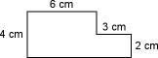

5. Calculate the area of the following figure.

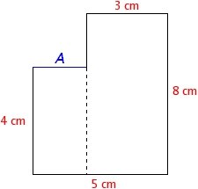

6. The area of a square is 58.6 m². Which is the length of each side?
7. Niko wants to paint 3 walls of his bedroom. One wall measures 8 ft by 7 ft while the other
wall is 12 ft by 7 ft. What is total area, in metres, of the two walls that Niko wants to paint?
8. Hayden determined that the area of his porch was 226 sq ft. If concrete costs $19.50 per sq
yd, how much will cost Hayden to use concrete for his porch?
9. A brick layer needs to order supplies for installing a brick patio. The dimensions of a
patio are10 feet by 14 feet. Find the area of the patio in square meters. (round to 2 decimal places)
10. Tanner’s sprinkler spreads water in a circular pattern. When he fully opens the faucet, the
circle has a diameter of 14.5 ft. What area does his sprinkler cover? Use 3.14 for π.

11. Calculate the area of the following figure.
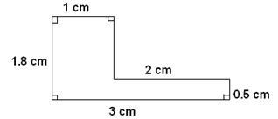

12. A rectangular door is 7 feet long and 34 inches wide. Which is the area of the door?

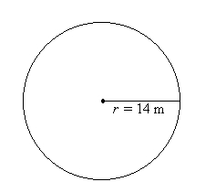
13. Determine the area of the following figures.
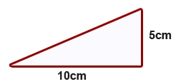
A) B)

C) D)




