Science 3200 – Midterm Review

Definitions:
- Chemistry
- Matter
- Atom
- Element
- Compound
- Pure Substance
- Mixture
- Homogenous Mixture
- Heterogeneous Mixture
- WHMIS
- MSDS
- Chemical Property
- Physical Property
- Chemical Change
- Physical Change
- Periodic Table
- Group
- Period
- Metal
- Non-metal
- Protons
- Neutrons
- Electrons
- Nucleus
- Energy Level Diagram (Bohr Diagram)
- Valence Level
- Ion
- Cation
- Anion
- Ionic Compound
- Molecular Compound

Review Questions:
- What is the difference between an element and an atom?
- What is the difference between an element and a compound?
- How many different elements are in:
  - CH₄
  - NaNO₃
  - F₂
- How many atoms are in the compounds in question #3
- For each WHMIS symbol shown below, write what it represents

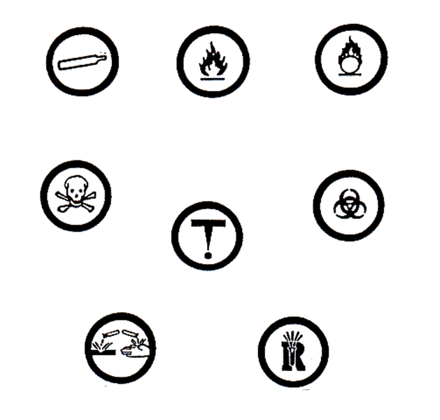
- Write down 5 rules to obey when you go to the lab
- List 5 different pieces of information you can find on an MSDS.
- Give 3 examples of physical properties
- Give 3 examples of chemical properties
- List 5 metals and 5 non-metals
- For each element you listed in #10, write down its group and period
- For each element you listed in #10, find the number of protons, neutrons and electrons
- Draw an energy level diagram for:
  - He
  - F
  - Mg
  - S
- For each element in #13, determine the number of valence electrons
- Identify each ion as a cation or anion:
  - Ca²⁺
  - F⁻
  - O²⁻
  - Na⁺
- For each ion in #15, determine the number of protons, neutrons and electrons
- Draw an energy level diagram for each element in #15
- For each compound, identify as being ionic or molecular
  - N₂O
  - CaBr₂
  - C₂H₄
  - MnO₂
  - KCl
  - P₃Cl₄
- Determine the name for the molecular compounds listed in #18.

